**Adding monitoring to your WebApi with Grafana**

|  |  |
| --- | --- |
| **Version control** | |
| Author | Marcos Lara |
| When | 10-May-2024 |
| Why | Provide a step-by-step guide to implement Grafana monitoring. |
| Version | 1.0 |

1. **Create a minimal API in .NET:**

dotnet new webapi -n Monitoring

cd Monitoring

1. **Install the following NuGet packages into your project.**

|  |  |  |
| --- | --- | --- |
| **Top-level Package** | **Requested** | **Resolved** |
| Microsoft.AspNetCore.OpenApi | 9.0.4 | 9.0.4 |
| OpenTelemetry | 1.12.0 | 1.12.0 |
| OpenTelemetry.Exporter.Console | 1.12.0 | 1.12.0 |
| OpenTelemetry.Exporter.Prometheus.AspNetCore | 1.12.0-beta.1 | 1.12.0-beta.1 |
| OpenTelemetry.Extensions.Hosting | 1.12.0 | 1.12.0 |
| OpenTelemetry.Instrumentation.AspNetCore | 1.12.0 | 1.12.0 |
| OpenTelemetry.Instrumentation.Http | 1.12.0 | 1.12.0 |
| Serilog | 4.2.0 | 4.2.0 |
| Serilog.AspNetCore | 9.0.0 | 9.0.0 |
| Serilog.Extensions.Hosting | 9.0.0 | 9.0.0 |
| Serilog.Sinks.Console | 6.0.0 | 6.0.0 |
| Serilog.Sinks.Loki | 3.0.0 | 3.0.0 |

Run these instructions in the command line:

dotnet add package Microsoft.AspNetCore.OpenApi --version 9.0.4

dotnet add package OpenTelemetry --version 1.12.0

dotnet add package OpenTelemetry.Exporter.Console --version 1.12.0

dotnet add package OpenTelemetry.Exporter.Prometheus.AspNetCore --version 1.12.0-beta.1

dotnet add package OpenTelemetry.Extensions.Hosting --version 1.12.0

dotnet add package OpenTelemetry.Instrumentation.AspNetCore --version 1.12.0

dotnet add package OpenTelemetry.Instrumentation.Http --version 1.12.0

dotnet add package Serilog --version 4.2.0

dotnet add package Serilog.AspNetCore --version 9.0.0

dotnet add package Serilog.Extensions.Hosting --version 9.0.0

dotnet add package Serilog.Sinks.Console --version 6.0.0

dotnet add package Serilog.Sinks.Loki --version 3.0.0

Check if all packages were installed successfully:

dotnet list package

Get more information about the packages:

dotnet list package --include-transitive

Check if you have some outdated packages:

dotnet list package-- outdated

1. **Modify your Program.cs**

Add these lines:

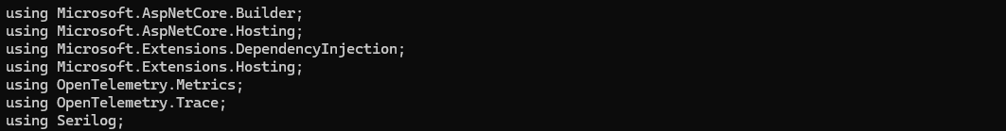

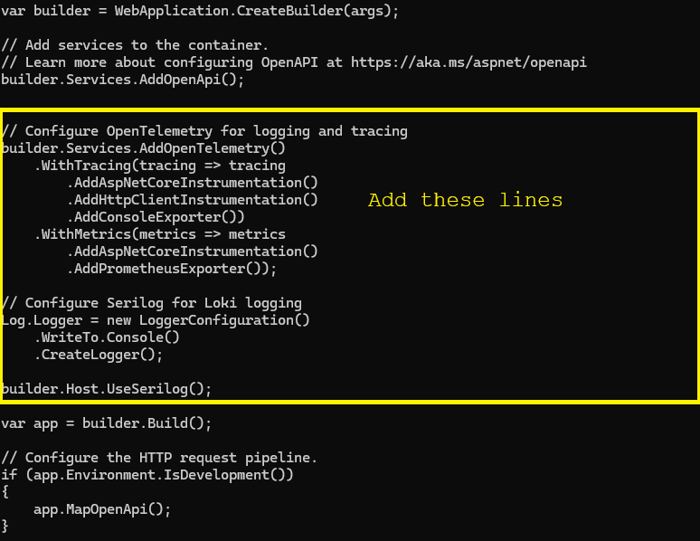

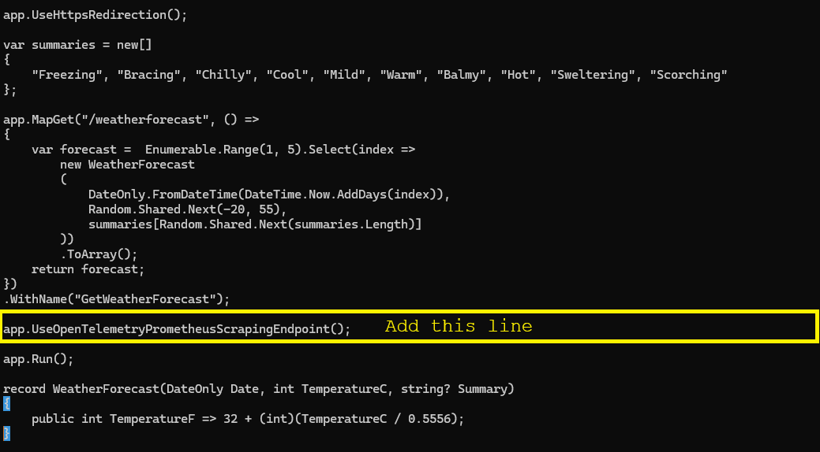

1. **Compile and test.**
2. Run your Grafana sever:

**Check if your servers are up and running.**



If not, refer to the document [load_grafana.md](https://github.com/marcoslaranz/dotnet_tips/blob/main/load_grafana.md) to learn how to run these containers.

1. **Run your application**

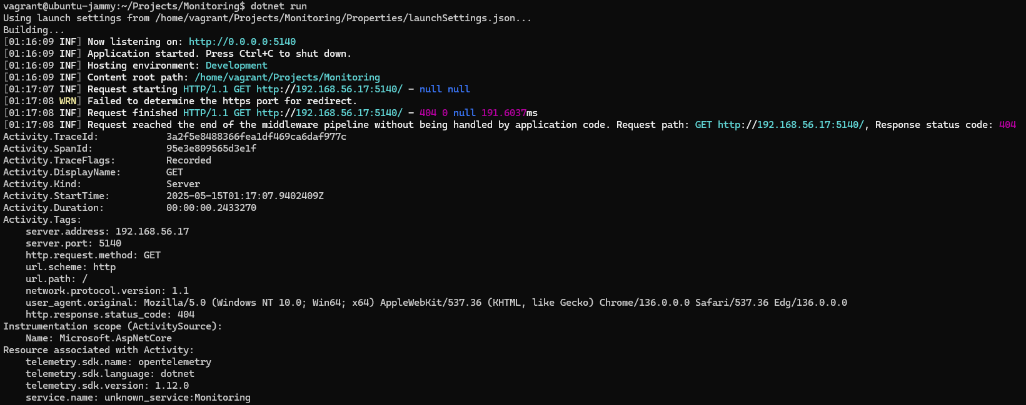

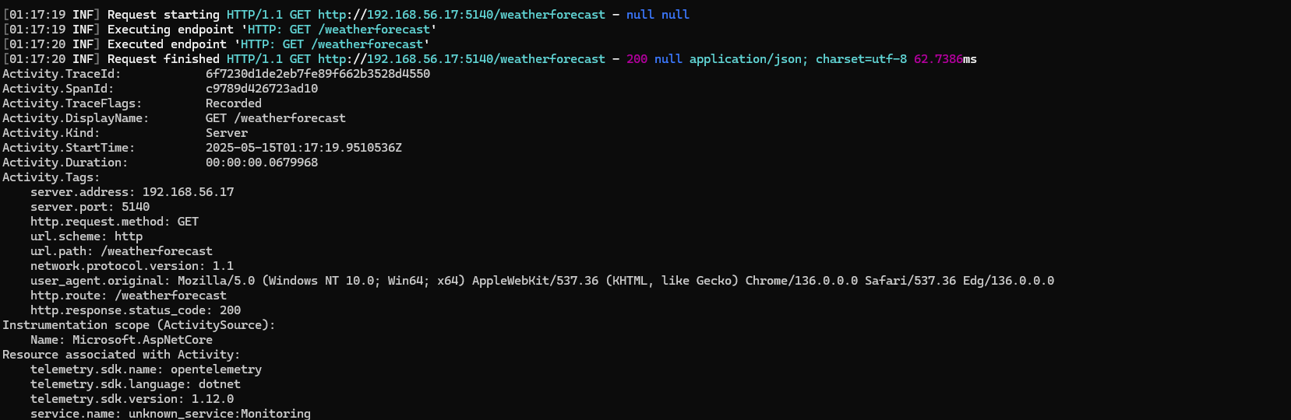

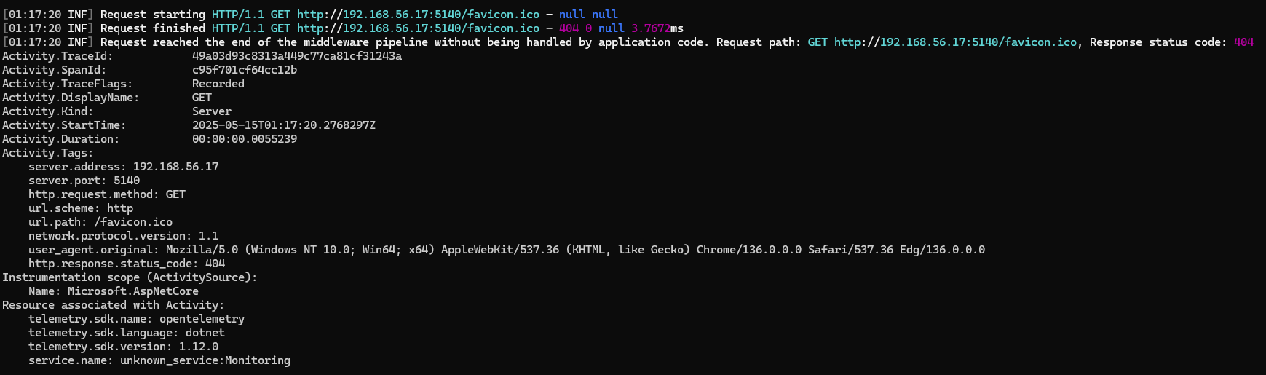

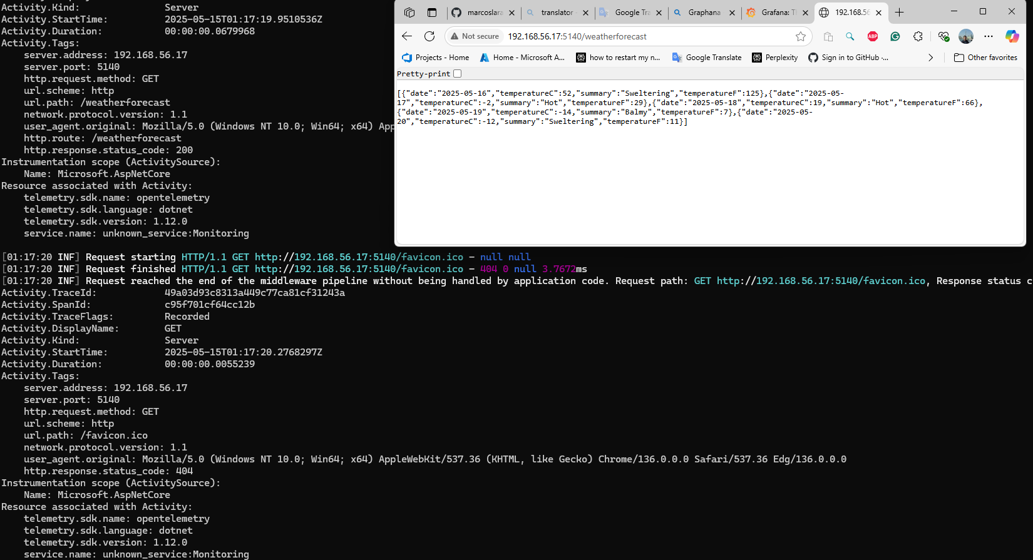

1. **Access Grafana.**

At first time use:

Username: admin,

Password: admin

Please, to find out how to configure and create dashboards, go to [Grafana: The open and composable observability platform | Grafana Labs](https://grafana.com/)

Or following the guides in the application

